Deployment of app in IBM Cloud Upload the image to IBM container Registry

|  |  |
| --- | --- |
| Team ID | PNT2022TMID39592 |
| Project Name | CUSTOMER CARE REGISTRY |

**Step 1.** In IBM Cloud Kubernetes Service, click the repositories in container registry.

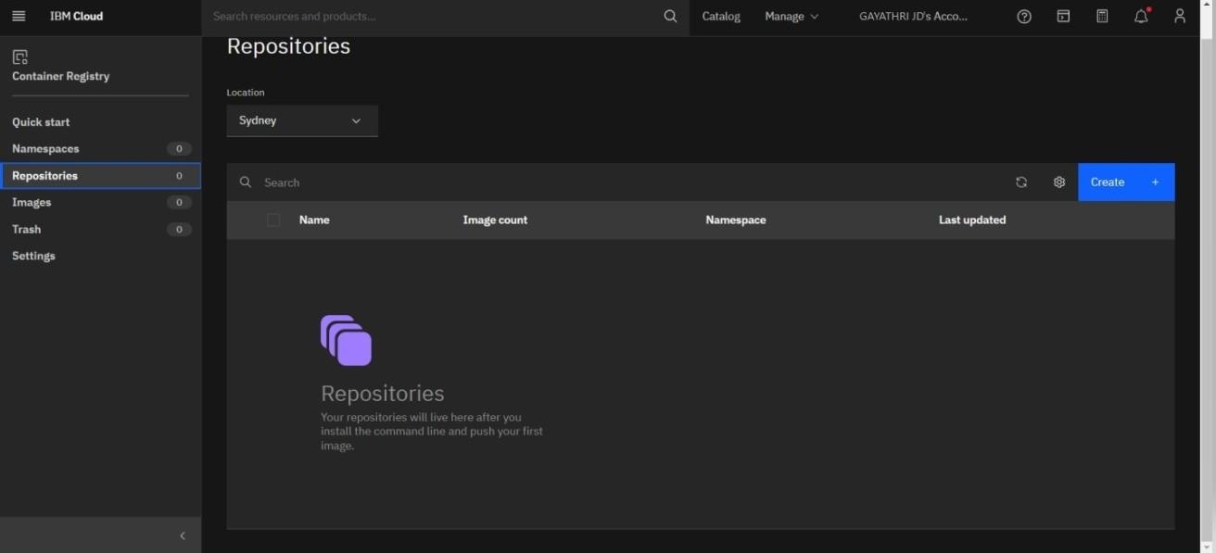

**Step 2**. Install the container registry plugin.

**Step 3**. Login to the IBM Cloud account.

**Step 4.** Login to docker and push the image to the IBM Container Registry.

